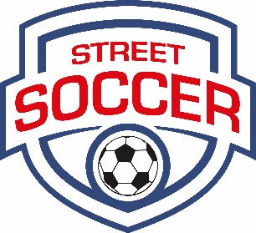
‘Meet the Professionals’
Young Person Evaluation Form

Your Name: | Your Organisation:

Please complete this form as a brief feedback guide to assist us and the Street Soccer team to evaluate the personal development and progress of the young people best effectively from those you have met with today.
Please provide appropriate comments in the space(s) below.

Overall Score Rating (1-5) for the Young People met: [ ] | - Outstanding  4. Very Good  3. Competent – acceptable behaviour | - Below Average – Did not come across as you would have expected  1. Unacceptable/Poor

 | Rating
Using the Score Rating legend from above, please TICK a Score Rating for each area below: | 5 | 4 | 3 | 2 | 1

Presentation Skills:
Your assessment of the young people’s presentation towards you and your organization.
Professional Impression:
Your view of the self-confidence and maturity attached to the young people’s level of professionalism presented.
Motivation/Initiative:
Your perception of the young people’s ability to think independently and their goal orientation.
Interpersonal/Communication Skills:
Your assessment of the young people’s ability to express their ideas and thoughts clearly in discussion.
Organisational Fit:
Your overriding review of the young people’s suitability and/or potential to fit into your company for a trainee / entry level role.

Overall Evaluation:
Please add any specific/additional comments below:

Note any thoughts or perceptions you have of the young people you have met today – kindly being considerate of their current circumstances and development journey they are on. If any young person(s) stood out for you in particular or if you have any useful or encouraging feedback which we can provide any individual(s) – or concerns that should be considered. (Thank you)

** Please state below the name(s) of any individual(s) you would be willing to offer a Work Experience placement opportunity to – or who you would be willing to meet with again for a formal interview for an employed or voluntary position at your organization:

PLEASE WRITE THEIR NAME(S) HERE:

Thank you for your support of our young people today.

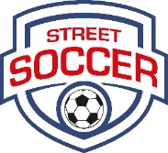
The Street Soccer Foundation
Changing Lives through Football

